**NAME-TANUL MUDGAL**

**UNN-1BM18CS116**

**PROGRAM 3-( SUPPLIER DATABASE)**

Consider the following schema:

SUPPLIERS(sid: integer, sname: string, address: string)

PARTS(pid: integer, pname: string, color: string)

CATALOG(sid: integer, pid: integer, cost: real)

The Catalog relation lists the prices charged for parts by Suppliers.

create database Supplier;

use Supplier;

create table catalog(sid int,pid int,cost int);

desc catalog;

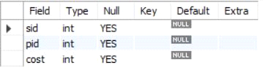

create table supplier(sid int,sname varchar(20),city varchar(15),primary key (sid));

desc supplier;

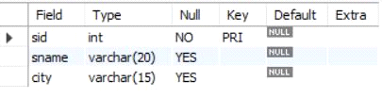

create table parts(pid int,pname varchar(15),color varchar(10),primary key (pid));

desc parts;

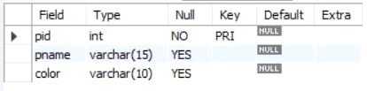

insert into supplier values(10001, 'Acme Widget','Bengaluru');

insert into supplier values(10002,'Johns','Kolkata');

insert into supplier values(10003, 'Vimal','Mumbai');

insert into supplier values(10004, 'Reliance','Delhi');

insert into supplier values(10005, 'Mahindra','Mumbai');

select * from supplier;

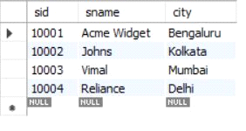

insert into parts values(20001, 'Book','Red');

insert into parts values(20002, 'Pen','Red');

insert into parts values(20003, 'Pencil','Green');

insert into parts values(20004, 'Mobile','Green');

insert into parts values(20005, 'Charger','Black');

select * from parts;

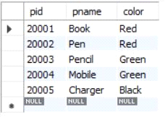

insert into catalog values(10001, '20001','10');

insert into catalog values(10001, '20002','10');

insert into catalog values(10001, '20003','30');

insert into catalog values(10001, '20004','10');

insert into catalog values(10001, '20005','10');

insert into catalog values(10002, '20001','10');

insert into catalog values(10002, '20002','20');

insert into catalog values(10003, '20003','30');

insert into catalog values(10004, '20003','40');

select * from catalog;

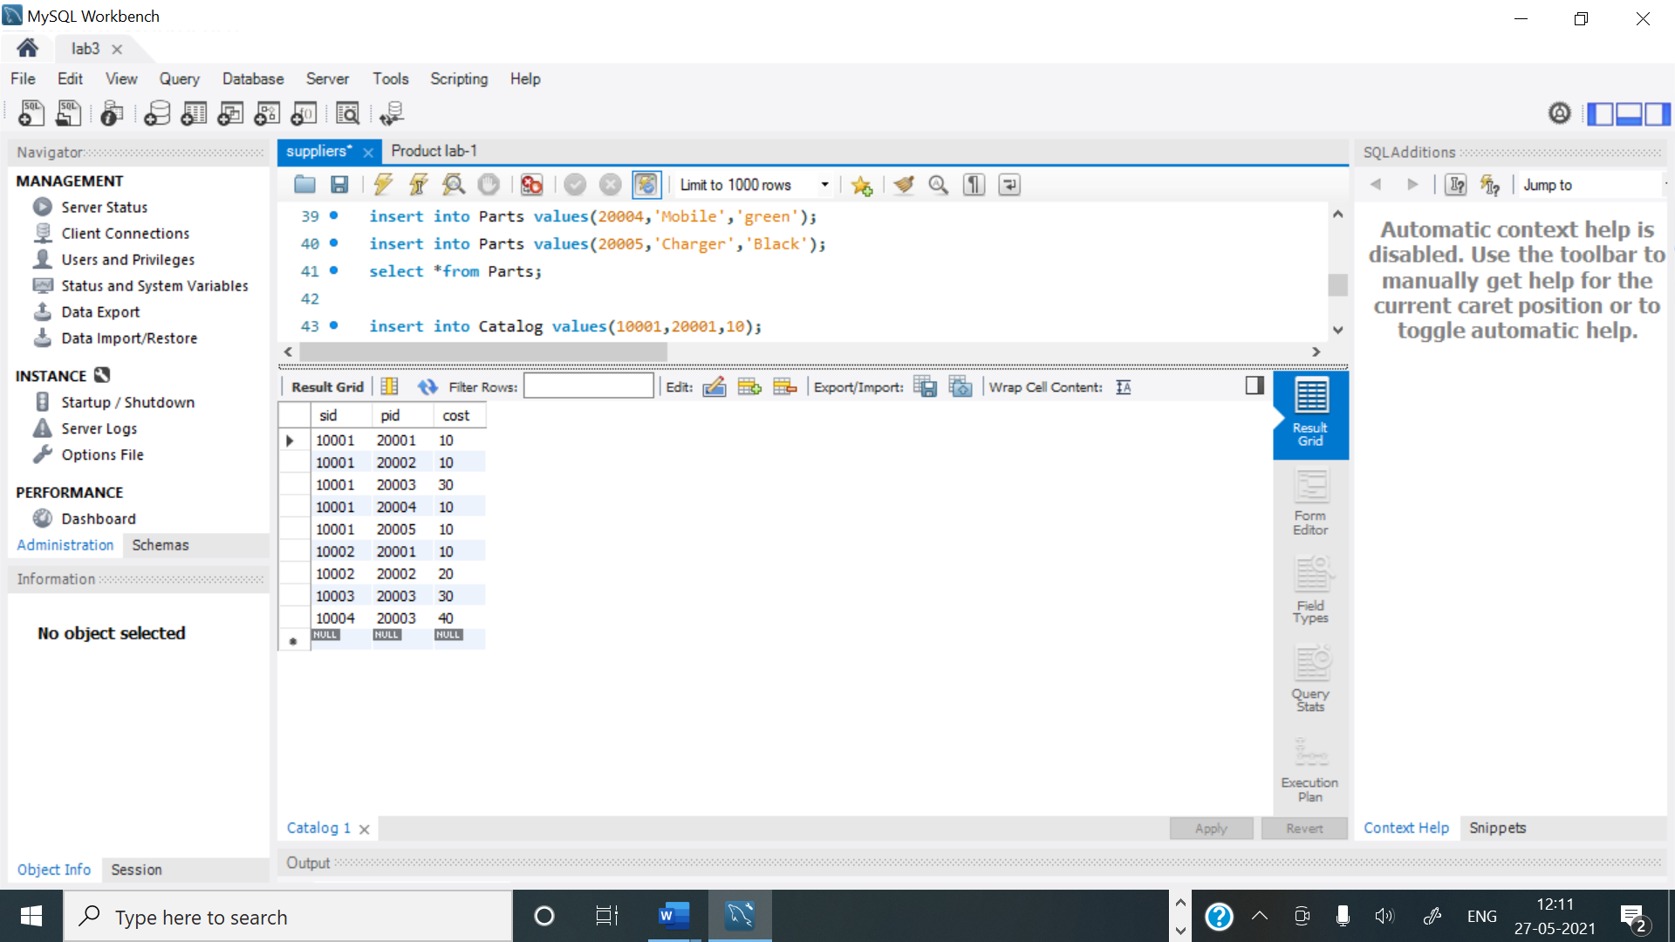

**1.Find the pnames of parts for which there is some supplier.**

select distinct p.pname from parts p, catalog c where p.pid = c.pid;

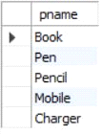

**2.Find the snames of suppliers who supply every part.**

select s.sname from supplier s

where not exists (select p.pid from parts p where not exists

(select c.sid from catalog c where c.sid = s.sid and c.pid = p.pid));



**3.Find the snames of suppliers who supply every red part.**

select s.sname from supplier s where not exists

(select p.pid from parts p where p.color = 'Red' and

(not exists (select c.sid from catalog c where c.sid = s.sid and c.pid = p.pid)));

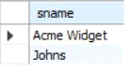

**4.Find the pnames of parts supplied by Acme Widget Suppliers and by no one else.**

select p.pname from parts p , catalog c, supplier s

where p.pid = c.pid and c.sid = s.sid and s.sname = 'Acme Widget'

and not exists

(select * from catalog c1, supplier s1 where

p.pid = c1.pid and c1.sid = s1.sid and s1.sname <> 'Acme Widget');

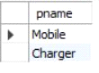

**5.Find the sids of suppliers who charge more for some part than the average cost of that part (averaged over all the suppliers who supply that part).**

select distinct c.sid from catalog c

where c.cost > ( select avg (c1.cost)

from catalog c1

where c1.pid = c.pid );

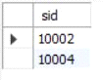

**6.For each part, find the sname of the supplier who charges the most for that part.**

select p.pid, s.sname

from parts p, supplier s, catalog c

where c.pid = p.pid

and c.sid = s.sid

and c.cost = (select MAX(c1.cost)

from catalog c1

where c1.pid = p.pid);

